Program No.: 04

**Aim:**

Create Functions to a given application.

**Topics covered:**

Handling Functions in python

**Course Outcome**

CO2: Implement basic data structures in python

**Case Studies:**

***Case Study 01:***

***Problem Statement:***

Python program to print the duplicate elements of an array using functions.

***Problem Solution:***

1. Define a function with name findDuplicates(a,size).
2. Declare and initialize an array.
3. Duplicate elements can be found using two loops. The outer loop will iterate through the array from 0 to length of the array. The outer loop will select an element. The inner loop will be used to compare the selected element with the rest of the elements of the array.
4. If a match is found which means the duplicate element is found then,

return the element to caller function.

***Program/Source Code:***

#Practice program to print the duplicate elements of an array using functions.

"""

Case study : 01

File name : cse1.py

Topics : Handling Functions in python

"""

# python script to print the duplicate elements of an array using functions.

#main method

def main():

size=int(input(“Enter Aray size:”))

a=[None]*size

#taking elements from user

for i in range(size):

a[i]=int(input(“Enter array element a[{0}]:”.format(i)))

#calling the function

findDuplicates(a,size)

#function to print duplicate elements

def findDuplicates(a,size):

#temporary array to store duplicate elements

repeated=[None]*size

print("Duplicate elemens are:")

for i in range(0,size):

for j in range(i+1,size):

if(a[i]==a[j] and a[i] not in repeated):

repeated.append(a[i])

print(a[i])

#drive code

main()

***Program Explanation:***

1. Define a function with name findDuplicates(a,size)
2. Declare and initialize an array.
3. Duplicate elements can be found using two loops. The outer loop will

iterate through the array from 0 to length of the array. The outer loop will select

an element. The inner loop will be used to compare the selected element with the

rest of the elements of the array.

4. If a match is found which means the duplicate element is found then,

return the element to caller function.

***Runtime Test Cases:***

1. Enter size:7

Enter array element a[0]: 2

Enter array element a[1]: 2

Enter array element a[2]: 4

Enter array element a[3]: 6

Enter array element a[4]: 8

Enter array element a[5]: 8

Enter array element a[6]: 8

Duplicate elemens are:

2

8

1. Enter size:4

Enter array element a[0]: 1

Enter array element a[1]: 2

Enter array element a[2]: 1

Enter array element a[3]: 2

Duplicate elemens are:

1

2

**Output:**

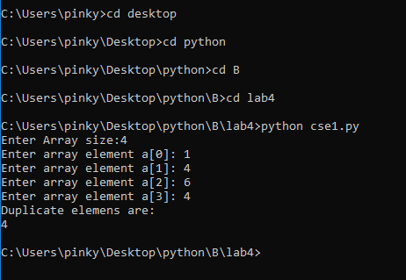

**Result:**

Implementation of basic concepts of Functions done successfully.

***Case Study 02:***

***Problem Statement:***

Create a Python function flip(A, dim) that takes a array of multi-dimension using python lists say it as A and a character dim that takes a value either “h” or “v” returns the array as a result of flipping the elements either horizontally or vertically. If dim variable is other than “h” or “v”, your function should return array unchanged. Note that your function should not change A itself, and should return the flipped array either horizontally or vertically.

***Problem Solution:***

1. Declare and initialize an multidimensional array arr.
2. Declare a character dim that takes a value either h or v.
3. If the character was ‘h’, then flip the matrix horizantally.
4. If the character was ‘v’, then flip the matrix vertically.
5. If the character was other than h and v,then return the original matrix.
6. Exit.

***Program/Source Code:***

#Practice program to return the matrix using functions.

"""

Case study : 02

File name : cse2.py

Topics : Handling Functions in python.

"""

# python script to return the matrix using functions

def flip(a,n):

r=len(a)

c=len(a[0])

if n=='h' or n=='H':

l=a

for i in range(r):

s=c//2

for j in range(s):

temp=l[i][j]

l[i][j]=l[i][c-1-j]

l[i][c-1-j]=temp

print("Elements after flipping horizantally")

for i in range(r):

for j in range(c):

print(l[i][j]," ",sep="",end="")

print()

elif n=='v' or n=='V':

l=a

for i in range(r//2):

temp=l[i]

l[i]=l[r-1-i]

l[r-i-1]=temp

print("Elements after flipping vertically")

for i in range(r):

for j in range(c):

print(l[i][j]," ",sep="",end="")

print()

else:

for i in range(r):

for j in range(c):

print(l[i][j]," ",sep="",end="")

print()

#main method

def main():

r=int(input("Enter the no of rows : "))

c=int(input("Enter the no of columns : "))

f=input("How you want to flip the elements : ")

arr=[]

for i in range(r):

a=[None]*c

for j in range(c):

a[j]=int(input("Enter the value :"))

arr.append(a)

print("The elements before flipping")

for i in range(r):

for j in range(c):

print(arr[i][j]," ",sep="",end="")

print()

flip(arr,f)

#drive code

main()

***Program Explanation:***

1. Declare and initialize an multidimensional array arr.
2. Declare a character dim that takes a value either h or v.
3. If the character was ‘h’, then flip the matrix horizantally.
4. If the character was ‘v’, then flip the matrix vertically.
5. If the character was other than h and v,then return the original matrix.
6. Exit.

***Runtime Test Cases:***

1. Enter the row size:2

Enter the column size:2

How You want to flip the elements: v

Enter the value:1

Enter the value:2

Enter the value:3

Enter the value:4

Elements Before Flipping:

1 2

3 4

Elements After Flipping Vertically:

3 4

1 2

1. Enter the row size:2

Enter the column size:3

How You want to flip the elements: h

Enter the value:1

Enter the value:2

Enter the value:3

Enter the value:4

Enter the value:5

Enter the value:6

Elements Before Flipping:

1 2 3

4 5 6

Elements After Flipping Horizontally:

3 2 1

6 5 4

**Output:**

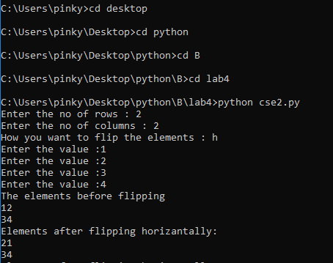

**Result:**

Implementation of basic concepts of Functions done successfully.

***Case Study 03:***

***Problem Statement:***

Write a Python function rotatelist(l,k) that takes a list l and a positive integer k and returns the list l after k rotations. If k is not positive, your function should return l unchanged. Note that your function should not change l itself, and should return the rotated list. Here are some examples to show how your function should work.

***Problem Solution:***

1. Declare and initialize an array.
2. Declare k and pass it to the function.
3. If the k value is negative,then return the normal list.
4. If the k value is positive,then right rotate the list k number of times.
5. Exit

***Program/Source Code:***

#Practice program to right rotate the list using function.

"""

Case study : 03

File name : cse3.py

Topics : Handling Functions in python.

"""

# python script to right rotate the list using functions.

#function to rotate list

def rotatelist(a,n):

print("Elements before rotation")

print(a)

s=len(a)

for i in range(n):

temp=a[s-1]

for j in range(s-1,0,-1):

a[j]=a[j-1]

a[0]=temp

print("Elements after rotation")

print(a)

#main method

def main():

s=int(input("Enter the size of the array : "))

n=int(input("Enter the no of times you want to rotate : "))

a=[None]*s

for i in range(s):

a[i]=int(input("Enter the value:"))

rotatelist(a,n)

#drive code

main()

***Program Explanation:***

1. Declare and initialize an array.
2. Declare k and pass it to the function.
3. If the k value is negative,then return the normal list.
4. If the k value is positive,then right rotate the list k number of times.
5. Exit.

***Runtime Test Cases:***

1. Enter the size of the array:5

Enter the no of times you want to rotate :1

Enter the value:1

Enter the value:2

Enter the value:3

Enter the value:4

Enter the value:5

Elements before rotation:

[1,2,3,4,5]

Elements after rotation:

[5,1,2,3,4]

1. Enter the size of the array:5

Enter the no of times you want to rotate :1

Enter the value:1

Enter the value:2

Enter the value:3

Enter the value:4

Enter the value:5

Elements before rotation:

[1,2,3,4,5]

Elements after rotation:

[3,4,5,1,2]

**Output:**

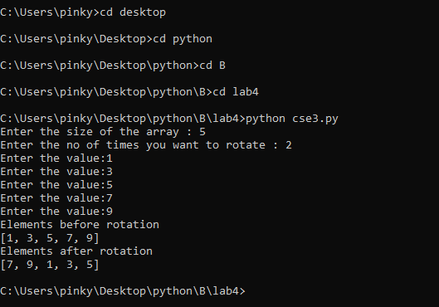

**Result:**

Implementation of basic concepts of Functions done successfully.

***Case Study 04:***

***Problem Statement:***

Create a Python function histogram(l) that takes as input a list of integers with repetitions and returns a list containing the frequency of each element in ascending order.

***Problem Solution:***

1. Declare a Python function histogram(l) that takes as input a list of

integers with repetitions

1. Declare cnt value as 0.
2. If the element is repeated,then increment the cnt value by one.

4. Set the encountered element as the key and the cnt as the value in the dictionary.

5. Set the values in the dictionary in order and store it in the list and print the list.

***Program/Source Code:***

#Practice program to print dictionary and store in list and print.

"""

Case study : 04

File name : cse4.py

Topics : Handling Functions in python.

"""

# python script to print dictionary and store in list and print.

#print the rotated array elements

#creating the function to display repeated elements

def histogram(l):

a=[]

b=[]

for i in l:

if(i not in b):

b.append(i)

else:

pass

for j in b:

r=[]

r.append(j)

r.append(l.count(j))

a.append(r)

return (a)

#main Function

def main():

s=int(input("Enter array size: "))

a=[]

print("Elements into the array:")

for i in range(s):

a.append(int(input("enter element a[{0}]".format(i))))

print(histogram(a))

#drive code

main()

***Program Explanation:***

1. Declare a Python function histogram(l) that takes as input a list of

integers with repetitions

1. Declare cnt value as 0.
2. If the element is repeated,then increment the cnt value by one.
3. Set the encountered element as the key and the cnt as the value

in the dictionary.

1. Set the values in the dictionary in order and store it in the list and print the list.

***Runtime Test Cases:***

1. Enter array size: 11

Elements into the array:

enter element a[0]13

enter element a[1]12

enter element a[2]11

enter element a[3]13

enter element a[4]14

enter element a[5]3

enter element a[6]7

enter element a[7]7

enter element a[8]13

enter element a[9]14

enter element a[10]12

[[13, 4], [12, 2], [7, 2], [14, 2], [11, 1]]

1. Enter array size: 5

Elements into the array:

enter element a[0]1

enter element a[1]2

enter element a[2]1

enter element a[3]3

enter element a[4]2

[[1, 2], [2, 2], [3, 1]]

**Output:**

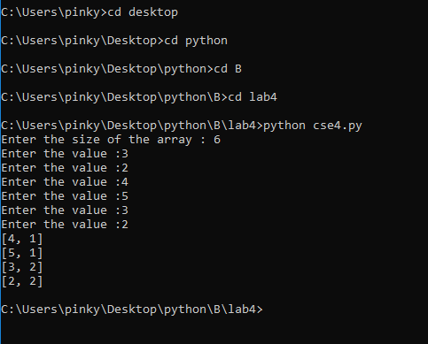

**Result:**

Implementation of basic concepts of Functions done Successfully.

***Case Study 05:***

***Problem Statement:***

Define the function with name fine ( car_num , date ) with given a date( in integer ) and an array of integer containing the numbers of the cars traveling on that date (an integer), the task is to calculate

the total fine collected based on the following rules: Odd numbered cars can travel on only odd dates.

Even numbered cars on only even dates. Otherwise a car would be fined 250 Rs..

***Problem Solution:***

1. Declare the function with name fine ( car_num , date ) with given a date( in integer ) and an array of integer containing the numbers of the cars traveling on that date (an integer).

2. If the date was an odd number,then odd numbered cars can travel only.

3. If the date was an even number,then even numbered cars can travel only.

4. Otherwise a car would be fined 250 Rs.

***Program/Source Code:***

#Practice program to print duplicate elements of an array

"""

Case study : 05

File name : cse5.py

Topics : Handling Functions in python.

"""

# python script to print cars with even and odd numbered.

#main method

def main():

size=int(input("Enter No of Cars:"))

a=[None]*size

date=int(input("Enter the date:"))

#taking elements from user

for i in range(size):

a[i]=int(input("Enter the Value: "))

#calling the function

fine(a,date)

# function to find the total fine

def fine(a,date):

arr=[]

total=0

j=-1

for i in range(0,len(a)):

if(((a[i]^date)&1)==1):

total+=250

arr.append(a[i])

print("The total fine is",total)

print("cars with numbers",arr,"are fined 250 each")

#drive code

main()

***Program Explanation:***

1: Declare the function with name fine ( car_num , date ) with given a date( in integer ) and an array of integer containing the numbers of the cars traveling on that date (an integer).

2. If the date was an odd number,then odd numbered cars can travel only.

3. If the date was an even number,then even numbered cars can travel only.

4. Otherwise a car would be fined 250 Rs.

***Runtime Test Cases:***

1. Enter Number Of Cars:3

Enter the date:16

Enter value:1

Enter value:2

Enter value:3

The total fine is:500

Cars with numbers 1 and 3 will be fined 250Rs each.

2. Enter Number Of Cars:4

Enter the date:15

Enter value:3

Enter value:4

Enter value:1

Enter value:2

The total fine is:500

Cars with numbers 4 and 2 will be fined 250Rs each.

**Output:**

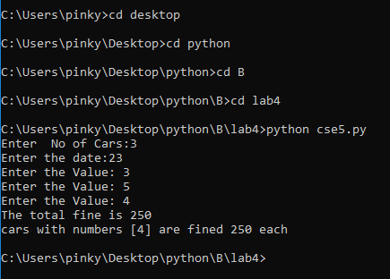

**Result:**

Implementation of basic concepts of Arrays done successfully.